Types of Lexicons
# Source: Chatgpt (GPT-4-turbo) at [7/29/2025]
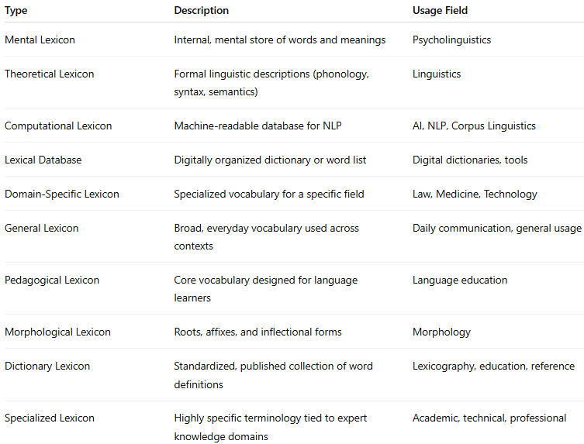

Type | Description | Usage Field
Mental Lexicon | Internal, mental store of words and meanings | Psycholinguistics
Theoretical Lexicon | Formal linguistic descriptions (phonology, syntax, semantics) | Linguistics
Computational Lexicon | Machine-readable database for NLP | AI, NLP, Corpus Linguistics
Lexical Database | Digitally organized dictionary or word list | Digital dictionaries, tools
Domain-Specific Lexicon | Specialized vocabulary for a specific field | Law, Medicine, Technology
General Lexicon | Broad, everyday vocabulary used across contexts | Daily communication, general usage
Pedagogical Lexicon | Core vocabulary designed for language learners | Language education
Morphological Lexicon | Roots, affixes, and inflectional forms | Morphology
Dictionary Lexicon | Standardized, published collection of word definitions | Lexicography, education, reference
Specialized Lexicon | Highly specific terminology tied to expert knowledge domains | Academic, technical, professional

